Welcome back to Popular Movies! In this second and final stage, you’ll add additional functionality to the app you built in Stage 1.

You’ll add more information to your movie details view:

* You’ll allow users to view and play trailers ( either in the youtube app or a web browser).
* You’ll allow users to read reviews of a selected movie.
* You’ll also allow users to mark a movie as a favorite in the details view by tapping a button(star). This is for a local movies collection that you will maintain and does not require an API request*.
* You’ll modify the existing sorting criteria for the main view to include an additional pivot to show their favorites collection.

Lastly, you’ll optimize your app experience for tablet.

Recall from Stage 1, you built a UI that presented the user with a grid of movie posters, allowed users to change sort order, and presented a screen with additional information on the movie selected by the user:

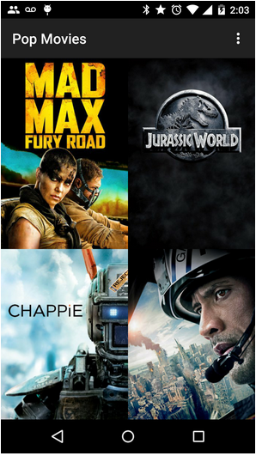

In Stage 2, you will go one step further and allow the user to view movie trailers, read reviews, and select favorites.

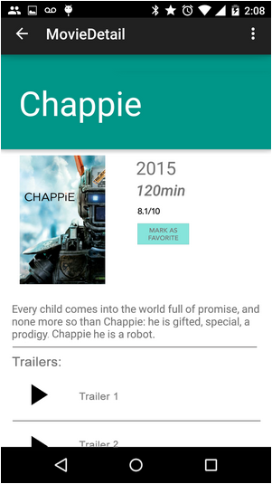

Lastly, you will take the entire end-to end-user interaction flow, including what you built in Stage 1, and optimize it to work on tablets.

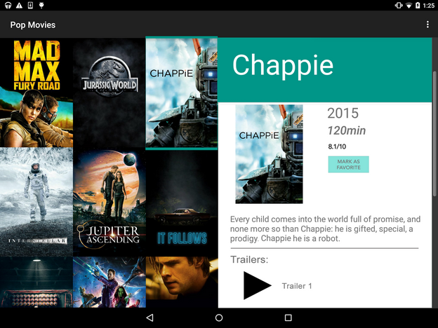

**What Will I Learn After Stage 2?**

* You will build a fully featured application that looks and feels natural on the latest Android operating system (Lollipop, as of May 2015).
* You will optimize the UI experience for both phones and tablets.

Ready to start building? Click "Next" for instructions!